Sales Forecasting Analysis
Sales Forecasting Analysis
Forecasting Model Used
The ARIMA forecasting model was used to predict future sales trends. This model was selected because it effectively captures patterns and trends in time-series sales data and performs well for business forecasting.
Data Preparation
The dataset was converted into a time series format by transforming the Date column into datetime format. Daily sales revenue was aggregated and missing dates were handled to ensure continuity in the data.
Forecast Results
Sales were forecasted for the next 6 months using the trained ARIMA model. The model identified trends and fluctuations in sales based on historical transaction data.
Seasonality and Trends
The sales data shows fluctuations over time, which may be influenced by customer demand, promotions, or seasonal buying patterns.
Model Performance
The forecasting accuracy was evaluated using:
- RMSE (Root Mean Squared Error)
- MAPE (Mean Absolute Percentage Error)
These metrics help measure how closely the predicted sales match actual sales data.
Business Recommendations
Based on the forecast results:
• Increase inventory during predicted high-sales periods
• Plan marketing campaigns during slow sales months
• Improve supply chain planning based on forecast demand
• Use predictive analytics for future business strategies

Sales Forecasting Visualizations
Historical vs Predicted Sales
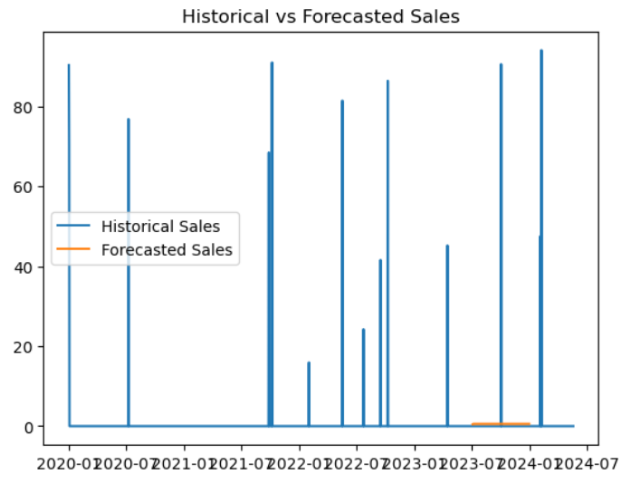
Monthly Sales Trend
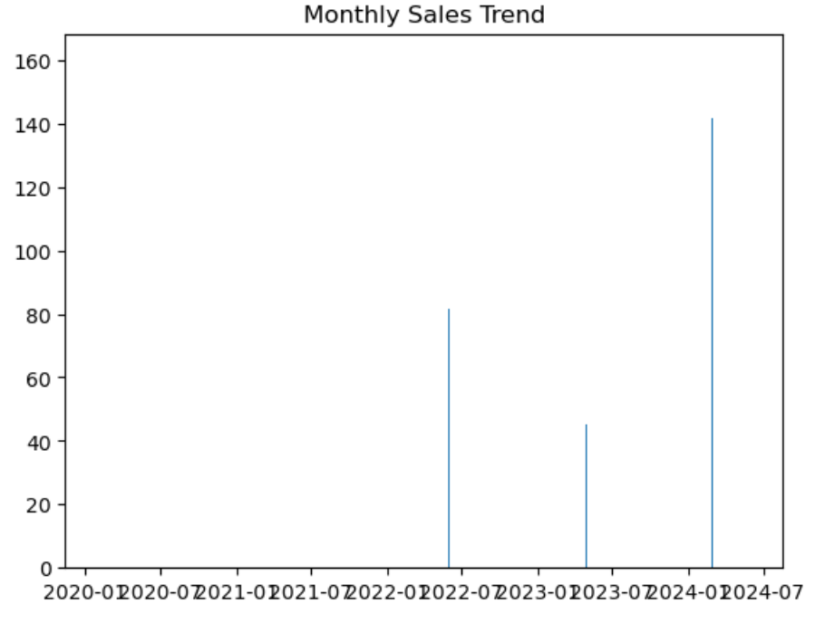

Long-Term Trend
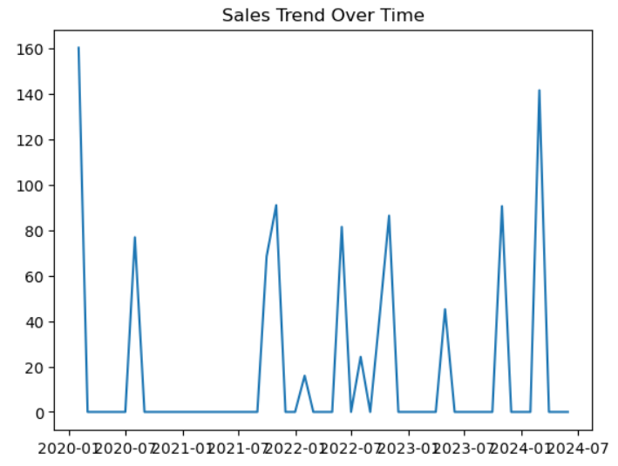

Model Performance Evaluation
The forecasting model was evaluated using RMSE and MAPE metrics. Some days in the dataset had zero sales values, which caused division issues during MAPE calculation. Therefore, zero sales records were excluded when computing MAPE to ensure accurate model performance evaluation.
The model achieved an RMSE of 7.73, indicating that the predictions are reasonably close to the actual sales values.
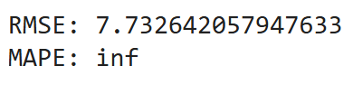
Updated Forecast Dataset (CSV)
http://localhost:8888/lab/tree/sales_forecast_dataset.csv

